**Sesame Glazed Ginger Green Beans**  
__________________________________________________________  
*This recipe makes use of Riverside’s farm-fresh green beans.*



**Ingredients**

* 1 pound green beans, trimmed
* 1 Tablespoon avocado oil, or other oil suitable for high heat
* 2 cloves garlic, minced
* 1 Tablespoon minced ginger
* 1/4 cup water
* 1 Tablespoon maple syrup
* 2 Tablespoons coconut aminos or soy sauce
* 1 Teaspoon toasted sesame oil
* 1/2 Teaspoon red pepper flakes
* Optional: 1-2 Teaspoons toasted sesame seeds as garnish

**Directions**

1. Place a 9-inch cast iron skillet over medium heat. When the pan is hot, add the avocado oil, garlic, and ginger. Sauté 30-45 seconds or until fragrant, then add the green beans to the pan and stir to distribute the garlic and ginger. Turn the heat up to medium high, and add the 1/4 cup water to the pan. Partially cover the pan with a lid placed slightly askew to steam/sauté. Stir every 1-2 minutes and continue to cook until the water is gone, about 6-7 minutes, or until the green beans are bright green and crisp tender.
2. Remove the lid, and turn the heat up to high. Add the maple syrup, coconut aminos, sesame oil, and red pepper flakes. Cook stirring continuously until the sauce reduces to a glaze like consistency, and almost all liquid is gone in the pan, 1-2 minutes.
3. Place the finished green beans in a serving dish, sprinkle with the optional sesame seeds, and serve immediately.

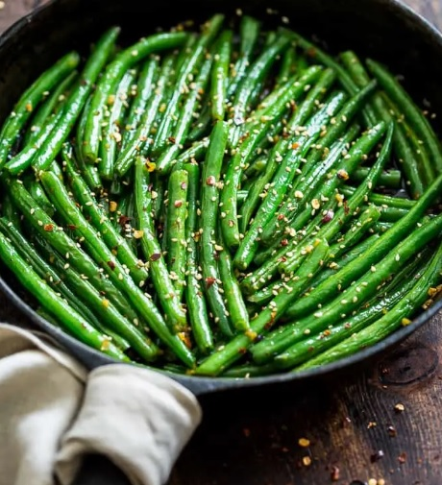

yields: 5 servings | source:  [getinspiredeveryday.com](http://r20.rs6.net/tn.jsp?t=o44bktabb.0.0.8iskahdab.0&id=preview&r=3&p=https%3A%2F%2Fgetinspiredeveryday.com%2Ffood%2Fsesame-ginger-glazed-green-beans%2F)