**Radish Relish**  
__________________________________________________________  
*This recipe makes use of Riverside’s farm-fresh radishes.*



**Ingredients**

* 4 to 5 bunches radishes (a little over 2 pounds)
* 1 large onion
* 2 cloves peeled garlic
* 2 cups vinegar
* 1 1/2 cups sugar
* 1 tbsp salt (use pickling salt if you intend on processing)
* 1 tbsp whole coriander
* 1 tbsp cumin seed
* 1 tbsp mustard seed
* 1/4 tsp ground black pepper
* 2-inch length of fresh ginger, peeled and grated (do not put in food processor, it makes it look ‘hairy’)

**Directions**

1. Clean and rinse radishes.
2. Place radishes, garlic and onion in food processor to finely chop.
3. In a large pot, combine vinegar, sugar, salt, coriander, cumin, mustard seed, black pepper and ginger. Let come to a boil, stirring to dissolve sugar.
4. Add radish mixture and bring to a boil and cook for 10 minutes.
5. Let cool and place in container to store in fridge. Or if you want to can this, leave 1/4 inch head space and water bath process for 20 minutes.

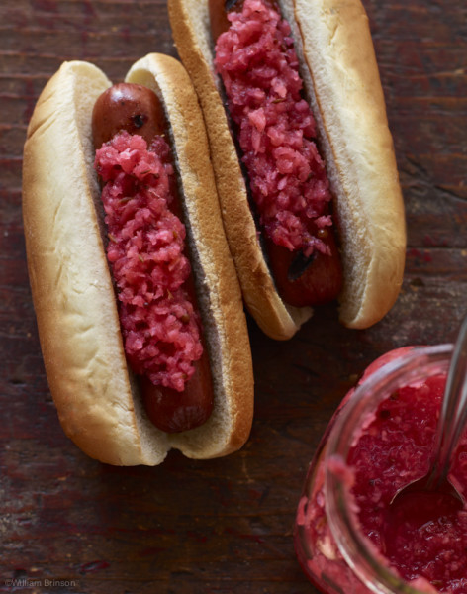  
Source: [houseofbrinson.com](https://www.houseofbrinson.com/2013/06/18/radish-relish/)