**Pineapple Cucumber Salad**  
__________________________________________________________  
*This recipe makes use of Riverside’s farm-fresh cukes.*



**Ingredients**

* Finely grated zest of 1 medium lime
* 2 tablespoons freshly squeezed lime juice
* 1/2 teaspoon kosher salt, plus more as needed
* 1/4 teaspoon chili powder
* 1/8 teaspoon cayenne pepper
* 1 medium pineapple (about 3 1/2 pounds), peeled, cored, and cut into 1-inch cubes (about 5 cups)
* **Cucumbers** (about 2 pounds total), cut into 1/2-inch chunks
* 1/2 small red onion, thinly sliced
* 1/2 cup coarsely chopped fresh cilantro leaves and tender stems

**Directions**

1. Whisk together the zest, lime juice, salt, chili powder, and cayenne together in a large bowl.
2. Add the pineapple, cucumber, and red onion, and toss to combine.
3. Add the cilantro and toss gently to combine.
4. Cover and refrigerate for 20 minutes to let the flavors meld.
5. Taste and season with more salt as needed.

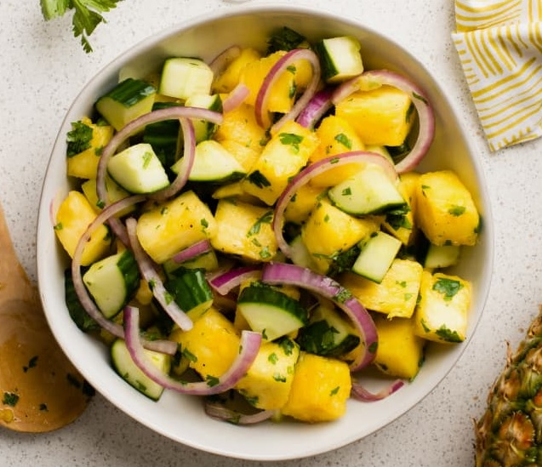

servings: 6  
adapted from: [thekitchn.com](https://www.thekitchn.com/pineapple-cucumber-salad-260384?fbclid=IwAR2piYf0SsF_cnY3a0-dfW62wnESgvyPjO6Zvz2JeWwm9IDUrk1Pu4DGh4E)