**Garlic Butter Roasted Parsnips**  
__________________________________________________________  
*This recipe makes use of Riverside’s spring-dug parsnips.*



**Ingredients**

* 2 to 2½ pounds parsnips
* 5 tbsp butter
* 4 cloves garlic, pressed
* ½ tbsp minced fresh rosemary (or any other fresh herbs)
* ¼ tsp salt
* ¼ tsp pepper
* Chopped fresh parsley, for garnish
* Crushed red pepper flakes, for garnish, optional

**Directions**

1. **Spread on a Baking Sheet.** Preheat oven to 450˚F. Spread out parsnips on rimmed baking sheet. Set aside.
2. Make the Garlic Butter. Melt the butter in a skillet set over medium heat. Stir in the garlic and cook for 20 seconds, or until fragrant. Remove from the heat and stir in the rosemary.
3. **Coat with the Garlic Butter.** Pour the garlic butter over the parsnips. Season with salt and pepper. Toss to coat. Spread parsnips out in a single layer.
4. **Roast.** Roast the parsnips in the preheated oven for 10 minutes. Then, give the parsnips a stir, and continue to roast for 8 to 10 more minutes, or until tender. Remove from the oven. Taste for salt and pepper, and adjust accordingly.
5. **Enjoy!** Garnish with parsley, crushed red pepper flakes (optional), and serve.

**Notes:**

**Smaller Is Better:** While large parsnips can be fine, they are more likely to have tough, woody cores which have to be cut away and discarded. Smaller parsnips are more likely to have tender, edible cores. Less prep!

**Peeling is Optional:** Most people peel their parsnips, but if you have found good small parsnips (preferably organic), you can simply scrub them as you would carrots or new potatoes, and leave the peel intact. It’s up to you! I like to leave the peel on.

**How to Cut:** You can cut the parsnips however you like of course, but the following method is very simple: Once you’ve cleaned the parsnips, cut them down the center, longwise. Then cut each half into 3 to 4 batons. From there, cut away any tough, woody core. If you like, halve the remaining pieces crosswise, leaving you with parsnip “fries” that are about 3 inches long.

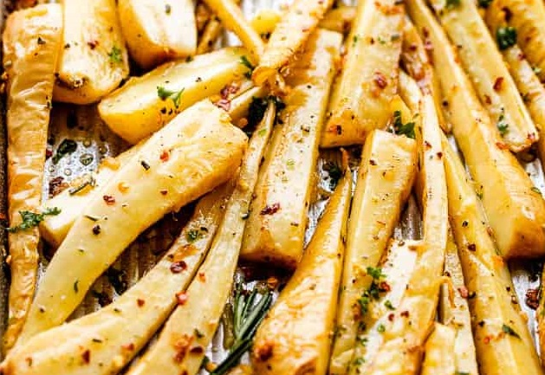

Source: [diethood.com](https://diethood.com/garlic-butter-roasted-parsnips/)