|  |  |
| --- | --- |
| |  | | --- | | Creamed Swiss Chard w/Bacon  This recipe can make use of Riverside’s farm-fresh Swiss Chard.  C:\Users\Jen\AppData\Local\Microsoft\Windows\INetCache\IE\VO1GFJSK\Vinilo_decorativo_gorro_chef_2[1].png  **Ingredients**  2 bunches (about 2 pounds) Swiss Chard  3 or 4 slices bacon, diced  1 clove garlic (mashed and finely minced)  1/4 to 1/2 cup red onion (finely chopped)  2 tablespoons butter  2 tablespoons flour  1 cup half-and-half or whole milk  pinch nutmeg  salt and pepper, to taste  **Directions**  Wash chard and cut off thicker stems. Thinly slice the stems and chop leaves into 1/2- to 1-inch pieces.  Steam or boil the stems for about 5 minutes, then add chard and cook until wilted, about 4 minutes longer. Drain well, squeezing out excess moisture if necessary.  In a medium saucepan over medium heat, cook the diced bacon until crisp; remove and set aside. Add onion and garlic and cook until onion is tender. Stir in the cooked drained chard and the reserved bacon; set aside.  In a saucepan over medium heat, melt butter. Stir in the flour until smooth and bubbly. Add the half-and-half or milk and nutmeg. Cook, stirring, until smooth and thickened. Add salt and pepper, to taste.  Add about 1/2 of the sauce to the chard, stirring to blend. Stir in more or all of the remaining sauce mixture, as desired | |

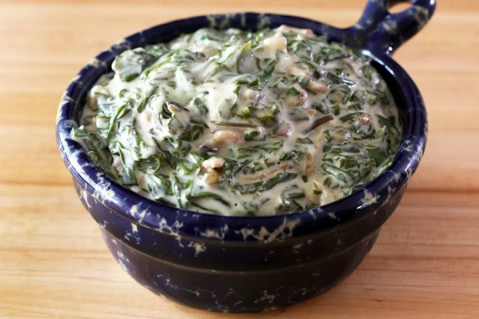

Source: [thespruce.com](https://www.thespruce.com/creamed-swiss-chard-with-bacon-3062030)