Crack Broccoli
This recipe makes use of Riverside’s farm-fresh broccoli.
Ingredients
- 1 and ½ pounds broccoli crowns (roughly 2 heads)
- ¼ cup extra virgin olive oil
- 4 garlic cloves, pressed
- large pinch of dried red pepper flakes
- ½ teaspoon kosher salt
- 3 tablespoons raw, sliced almonds (with or without skin)
- 2 teaspoons freshly squeezed lemon juice
- 2 – 3 tablespoons freshly grated aged pecorino cheese
- zest of half a lemon

Directions

- Preheat the oven to 475 degrees Fahrenheit. Note: The high temperature ensures even and deep caramelization (and extra crispy, flavorful florets!). If you prefer less crispy florets, you can reduce the oven temperature by 10 to 15 degrees Fahrenheit and adjust cooking time as necessary.
- Line a sheet pan with aluminum foil. Trim any dry, tough ends of the broccoli crowns, leaving roughly 2-inches of stalk attached. Slice the broccoli into ½-inch-thick steaks, starting in the center of each broccoli crown and working out to the edges, reserving any small or medium florets that fall off for roasting. Slice any large remaining florets in half lengthwise.
- In a large bowl, whisk together the olive oil, pressed garlic, and red pepper flakes. Add the broccoli steaks and toss gently until evenly coated. Arrange the broccoli, cut-side down, on the lined sheet pan, setting them apart slightly. Sprinkle with salt.
- Roast the broccoli for 10 to 12 minutes. Remove the pan from the oven, flip the broccoli, and sprinkle the almond slices evenly across the sheet pan. Roast for an additional 8 to 10 minutes, or until the broccoli is evenly caramelized and fork tender, and the almond slices are toasted and golden.
- Transfer the broccoli to a platter, toss gently with the lemon juice and top with the grated pecorino cheese. Garnish with fresh lemon zest. Serve hot or at room temperature (it also tastes great cold). Leftover broccoli can be stored in an airtight container in the fridge for up to 2 days.

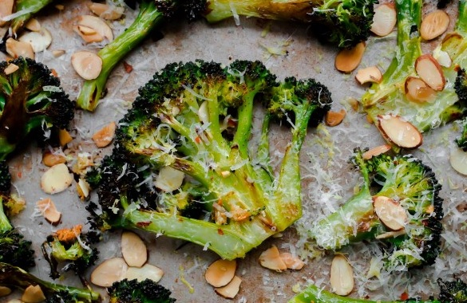
Photo & Recipe: abeautifulplate.com

Photo and recipe: Debi / Simply Beautiful Eating

