**Chicken w/Spinach & Mushrooms in Creamy Parmesan Sauce**  
__________________________________________________________  
*This recipe makes use of Riverside’s farm-fresh spinach.*



### Ingredients

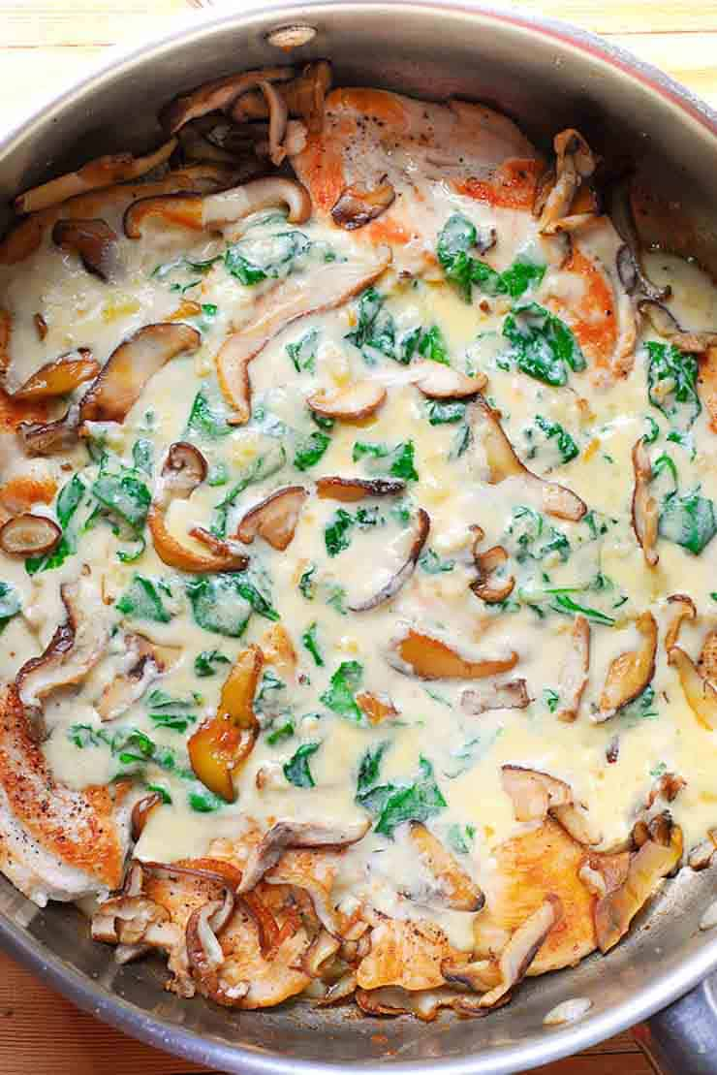

Source: [whatsinthepan.com](https://whatsinthepan.com/chicken-with-spinach-and-mushrooms-in-creamy-parmesan-sauce/)

* 2 Tbsp olive oil (divided)
* 4 Tbsp butter (divided)
* 4 chicken breasts halved crosswise
* Salt and pepper to taste
* 10 oz Cremini mushrooms (1 package) sliced

#### Creamy Parmesan Sauce:

* 4 cloves garlic minced
* 1 Tbsp wheat flour
* 1 cup chicken broth
* 1 cup heavy cream
* 1/2 cup grated Parmesan cheese
* 1/2 Tsp salt
* 1 tsp garlic powder
* 1/4 tsp black pepper
* 1 cup spinach

**Instructions**

* **Chicken:**Season chicken breasts with salt and pepper on large plate and set aside. Next in a large skillet, add 1 tablespoon of olive oil and 1 tablespoon butter. Allow for butter to melt over medium high heat. When the pan is hot, add chicken and cook for about 4 minutes on each side until browned for a total of 8 minutes. Remove it onto a plate.
* Now add the sliced mushrooms and remaining tablespoon of olive oil and 1 tablespoon butter to the pan. Cook for 5 minutes, your mushrooms should look nice and moist, and dark. Once cooked, remove them from the pan.
* **Sauce:** To make the sauce, add remaining butter to the pan, allow it to melt and then cook garlic in it until slightly browned – only for a couple of minutes. Add 1 tablespoon flour and cook until it's no longer raw. Slowly add chicken broth, heavy cream. Once simmering add Parmesan cheese and allow it to blend for 2-3 minutes. Add salt, garlic powder and pepper. Taste the sauce and adjust the seasoning, if necessary.
* Add spinach to the sauce and allow it to wilt.
* Next cooked mushrooms back into the pan and mix them into the sauce.
* Add cooked chicken and allow it to reheat for 2-3 minutes. Close the lid to help the heat stay in. Serve immediately! Spoon sauce all over chicken.