**Butternut Squash Minestrone**  
__________________________________________________________  
*This recipe makes use of Riverside’s winter squash.*



**Ingredients**

* 1 tablespoon olive oil
* 1 sweet onion diced
* 3 cloves garlic minced
* 12 oz cubed **butternut squash**
* 1 cup diced zucchini
* 1/2 teaspoon thyme
* 1/2 teaspoon sage
* 1/2 teaspoon salt
* 15 oz can white beans drained
* 28 oz fire-roasted crushed tomatoes
* 4 cups veggie broth
* 1/2 cup pasta
* 1 cup frozen or fresh kale

**Instructions**

1. Heat olive oil in large dutch oven or other heavy bottomed saucepan
2. Add diced onion and let cook for about 2-3 minutes
3. Add butternut squash and continue to sauté for 3-5 minutes
4. Add zucchini, garlic and spices and sauté for 2-3 more minutes
5. Add beans, tomatoes, broth and bring to a hard simmer
6. Add pasta and simmer 10 minutes until cooked
7. Add kale and simmer for 1-2 more minutes until heated through   
     
   *servings: 8 1-cup servings*

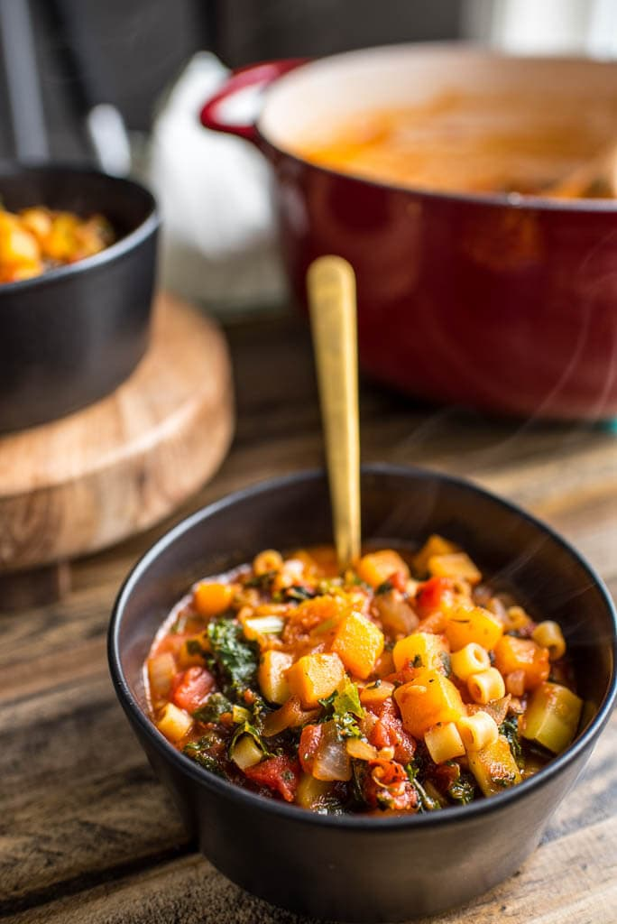

Source: [garnishedplate.com](https://garnishedplate.com/butternut-squash-minestrone/)