**Broccoli Salad**  
__________________________________________________________  
*This recipe makes use of Riverside’s farm-fresh broccoli.*



**NGREDIENTS**

* 5-6 cups raw broccoli florets
* 1 cup sharp cheddar cheese (thicker, not finely shredded)
* ⅔ cup dried cranberries
* ½ cup crumbled bacon
* ½ cup salted sunflower seeds
* ⅓ cup red onion diced into small pieces

**DRESSING**

* ¾ cup mayo
* ¼ cup sour cream
* 1 ½ Tablespoons white wine vinegar
* 3 Tablespoons sugar
* ¼ teaspoon salt
* ¼ teaspoon pepper

**INSTRUCTIONS**

1. Combine broccoli florets, cheddar cheese, dried cranberries, bacon, sunflower seeds, and onion in a large bowl.
2. In a separate, small bowl, whisk together mayo, sour cream, vinegar, sugar, salt, and pepper until smooth and well-combined.
3. Pour dressing over broccoli combination and toss or stir well.
4. Broccoli salad may be served immediately, but for best flavor refrigerate for at least one hour before serving. Make sure to toss broccoli salad thoroughly again before serving.
5. Keep refrigerated if not consuming right away.

Notes: pumpkin seeds are great on this, too. And golden raisins instead of cranberries are delicious!

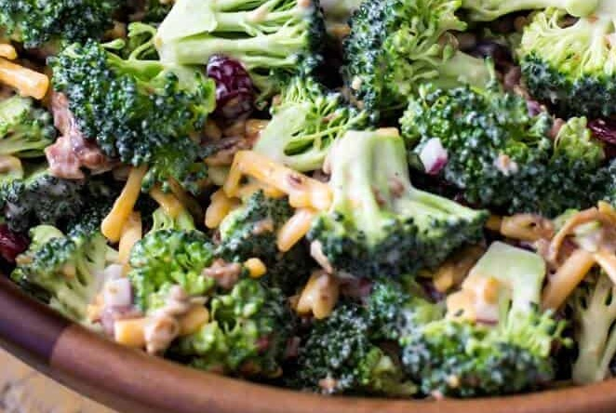

source: [sugarspunrun.com](https://sugarspunrun.com/broccoli-salad/)