|  |  |
| --- | --- |
| |  | | --- | | Roasted Beet Balsamic Mustard  C:\Users\Jen\AppData\Local\Microsoft\Windows\INetCache\IE\VO1GFJSK\Vinilo_decorativo_gorro_chef_2[1].png  This recipe can make use of Riverside’s farm-fresh beets.  **Ingredients**   * 2 Tablespoons Yellow Mustard Seeds * 2 Teaspoons Brown Mustard Seeds * 2 Tablespoons plus 2 Teaspoons Balsamic Vinegar * 2 Tablespoons plus 1 and 1/2 Teaspoons Water * 1 **Beet**, cleaned, peeled, and cut into quarters 1 Tablespoon Olive Oil * 1/2 Teaspoon Sea Salt * 1/2 Teaspoon Ground Black Pepper * 1/4 Teaspoon Brown Sugar   **Directions**   * In a sterilized 4-ounce canning jar, mix together the yellow mustard seeds, brown mustard seeds, balsamic vinegar, and water. Cover and allow to sit at room temperature for 2 days. * Toss the beet quarters with the pepper, olive oil, and 1/4 teaspoon of the salt and roast at 375 degrees for 35 minutes on a baking sheet lined with tin foil * In a blender or food processor, blend one of the beet quarters with the mustard, brown sugar, and remaining 1/4 teaspoon of salt until pureed but still slightly coarse * Use within 1 month * Makes about 4 Ounces (1/2 Cup) mustard | |

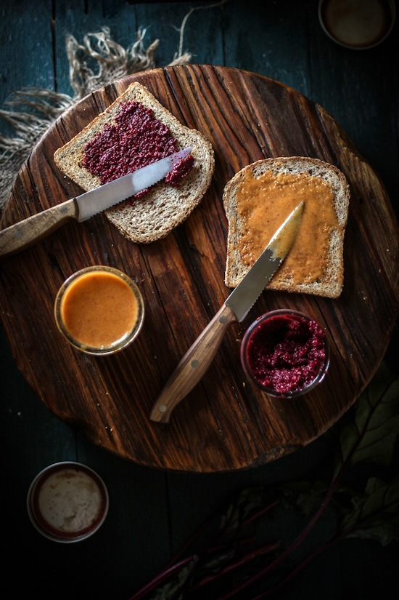

Recipe: [adventuresincooking.com](https://adventuresincooking.com/2013/04/roasted-beet-balsamic-mustard-honey.html)