**Maple Roasted Beets & Carrots**  
__________________________________________________________  
*This recipe makes use of Riverside’s beets and carrots.*



**Ingredients**

* 5 large carrots peeled & sliced
* 4 medium beets peeled & diced
* 2 tablespoons olive oil
* Salt & pepper to taste
* 2 tablespoons butter
* 3 tablespoons pure maple syrup

**Directions**

1. Preheat oven to 425F and move the rack to the middle position.
2. Cut the beets and carrots into pieces that are roughly the same size, and place the pieces on a large baking sheet.
3. Drizzle the olive oil onto the beets and carrots and add salt & pepper. Toss until they're coated. Spread them out in an even layer.
4. Roast for about 15 minutes, or until they veggies are tender-crisp (this will vary depending how big the pieces are).
5. Take the baking sheet out of the oven and add the butter and maple syrup directly to the baking sheet. Let the butter melt then toss it again until everything is coated.
6. Return the baking sheet to the oven for another 5 minutes.
7. Serve immediately.

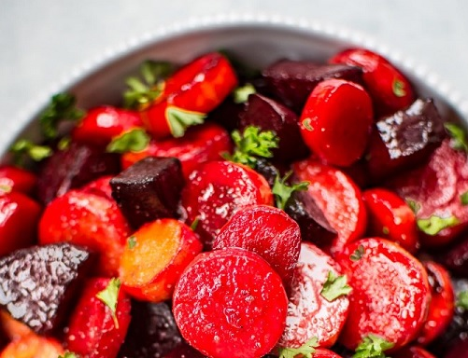

Source: [saltandlavender.com](https://www.saltandlavender.com/maple-roasted-beets-and-carrots/)